Hotel Management Website

Use-case Diagram

Version <1.0>

Revision History

|  |  |  |  |
| --- | --- | --- | --- |
| **Date** | **Version** | **Description** | **Author** |
| 26/11/2022 | 1.0 | Write Use-case Diagram | Tran Le Hoang Bao  Lam Vi Nguyen  Vu Huy Hoang |
|  |  |  |  |
|  |  |  |  |
|  |  |  |  |

Use-case Diagram

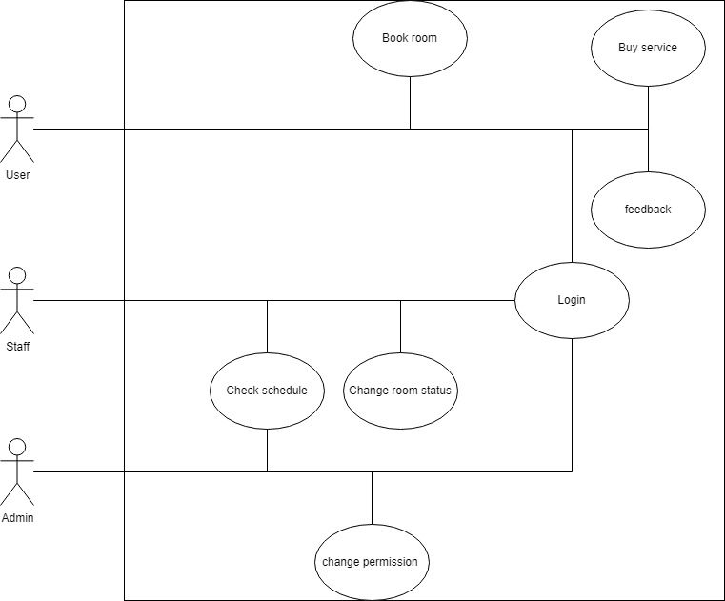

Use-case Specifications

|  |  |
| --- | --- |
| Use case ID | U001 |
| Use case name | Book room |
| Basic flow | 1.The user click the hotel they want to book room at  2.The website brings up the tab with available rooms appropriate to the user’s privilege  3.The user scrolls through the option and pick a room  4.The system sends the available room with information such as prices, reviews to the website  5.The website display the room information it received from the database  6.The user looks through the information for preference  7. The user pick the service in the checkbox  8.The website adds up the price for each feature chosen  9.The user click on the payment tab  10.The system brings up the page for payment  11.The user chooses their prefer payment method and pays  12.The website store the information to the database and pop up booking success |
| Alternative flow | 4. The database doesn’t have the information about the selected room so an error message is shown  7.The user doesn’t have enough privilege to use the feature so it will be grayed out  12.The user can’t pay for the room so the system won’t update the room status |
| Non-functional Requirements | No need |
| Pre-conditions | The user must have logged in |
| Post-conditions | The room is registered in the user’s personal information |

|  |  |
| --- | --- |
| Use case name | Login |
| use case ID | U002 |
| Description | For a user that have an account to login to the system |
| Actor | Admin, customer, staff, .. |
| Preconditions | The account must exist in the system database |
| Postconditions |  |
| Basic Flow | 1. Open app  2. System display login window  3. Input an account information  4. User press login button  5. System check login information  6. System display login success and display main window |
| Alternative Flows | 1. Step 5, system can’t find account in database, so it display wrong account or password |
| Non-functional requirement |  |

|  |  |
| --- | --- |
| Use case name | Buy service |
| Use case ID | U003 |
| Description | The user want additional service |
| Actor | Customer |
| Preconditions | The user must have booked a room |
| Postconditions | System add services into user database |
| Basic Flow | 1. The user navigate to service tab  2. The user scroll down the list to find the service they want  3. The user click the check box next to service  4. The user click the payment button  5. The system navigate user to payment method  6. The user choose payment method and click pay  7. The system announce success buying service |
| Alternative Flows | 1. Step 6, the user can’t pay for the service. The system will announce failed in payment and return user to service tab |
| Non-functional requirement |  |

|  |  |
| --- | --- |
| Use case name | Feedback |
| Use case ID | U004 |
| Description | The user can give feedback about their experience with the hotel |
| Actor | Customer |
| Preconditions | The user is logged in as a customer  The user has already booked a room |
| Postconditions | The user send the feedback to the hotel admin |
| Basic Flow | 1. User click history tab  2. The system send the history of the customer  3. The system display history onto window as a list of room they have booked  4. User click feedback option next to the room they have booked  5. User type their opinion in the dialog  6. User click send button  7. System will send the feedback to the hotel manager |
| Alternative Flows | 1. Step 3, user haven’t booked any room, so the system will display a blank window |
| Non-functional requirement |  |

|  |  |
| --- | --- |
| Use case name | Check schedule |
| Use case ID | U005 |
| Description | Check working schedule of staff |
| Actor | Staff, admin |
| Preconditions | User must be staff or admin |
| Postconditions |  |
| Basic Flow | 1. Navigate to schedule tab  2. System send schedule from the database  3. System will display schedule onto the window |
| Alternative Flows |  |
| Non-functional requirement |  |

|  |  |
| --- | --- |
| Use case name | Change room status |
| Use case ID | U006 |
| Description | Update room status |
| Actor | Staff |
| Preconditions | User must login as a staff |
| Postconditions |  |
| Basic Flow | 1. User navigate to manage tab  2. System will send list of room in staff’s hotel  3. User click update button next to the specific room  4. User changes the status of the room like availability, service, …  5. After changing, user click the update button  6. System send update information to the server  7. Server update the database |
| Alternative Flows |  |
| Non-functional requirement |  |

|  |  |
| --- | --- |
| Use case name | Change permission |
| Use case ID | U007 |
| Description | Update the permission of user |
| Actor | Admin |
| Preconditions | User must be logged in as an admin |
| Postconditions |  |
| Basic Flow | 1. Navigate to user management tab  2. The system send the list of user from database  3. The system display onto the window  4. Admin click on specific user  5. Admin check the box to add or remove user permission  6. The system send update to server  7. Server update the database |
| Alternative Flows |  |
| Non-functional requirement |  |